1. Table Creation:

CREATE TABLE Customers

(

Customerid char(5) not null,

CompanyName varchar(40) not null,

ContactName Char(30) null,

[Address] varchar(60) null,

City Char(15) null,

Phone Char(24) null,

Fax Char(24) null

)

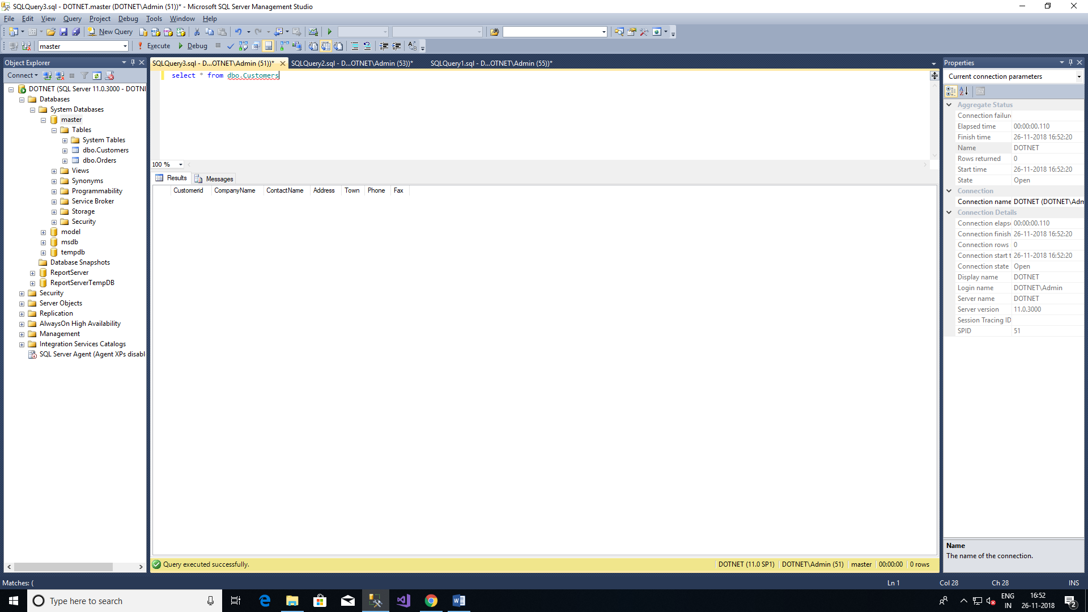

CREATE TABLE Orders

(

OrderId integer not null,

customerId char(5) not null,

Orderdate datetime null,

Shippeddate datetime null,

Freight money null,

Shipname varchar(40) null,

Shipaddres varchar(60) null,

Quantity integer null

)

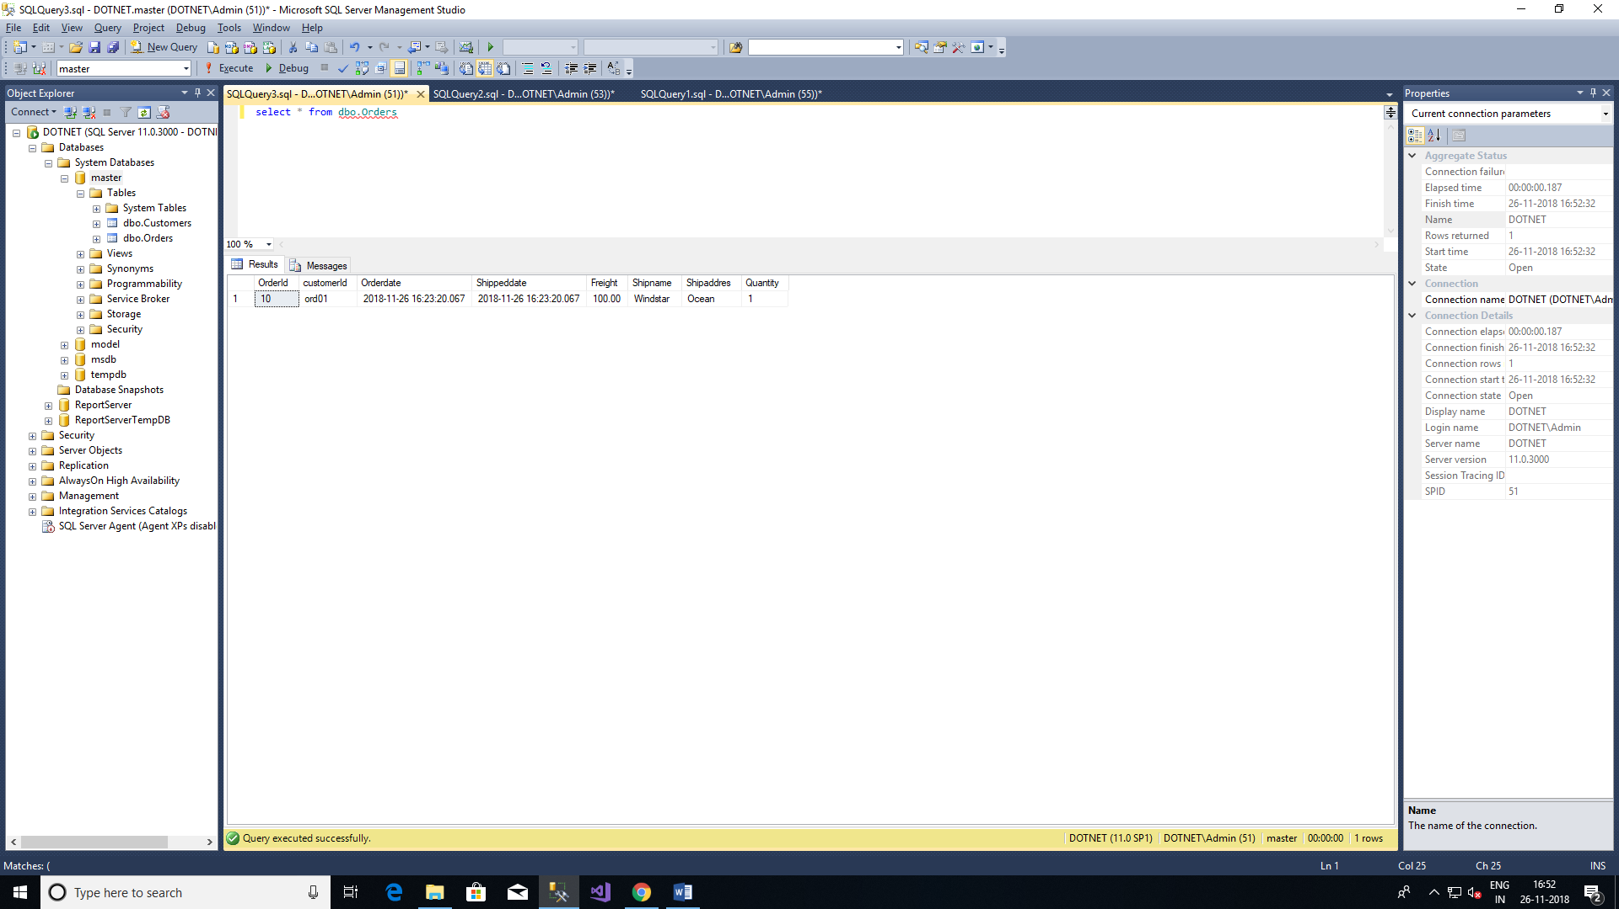

2. Alter table Order to Add ShipRegion

Alter table dbo.Orders

Add shipregion integer null

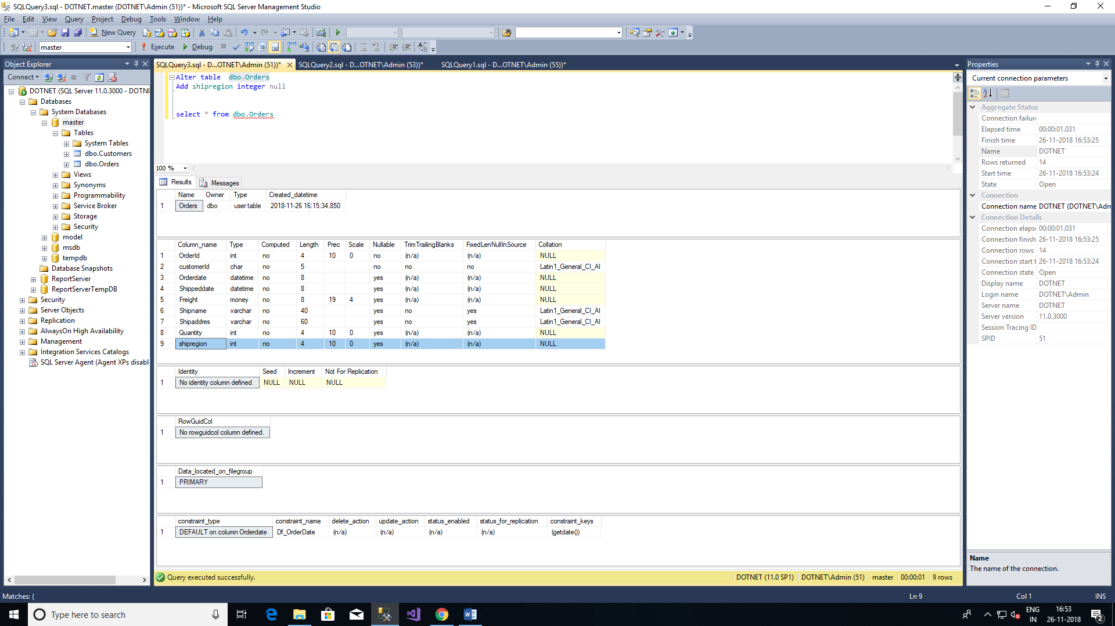

3. Alter Table Change Datatype of ShipRegion int to Char(8)

Alter table dbo.Orders

Alter column shipregion Char(8) null

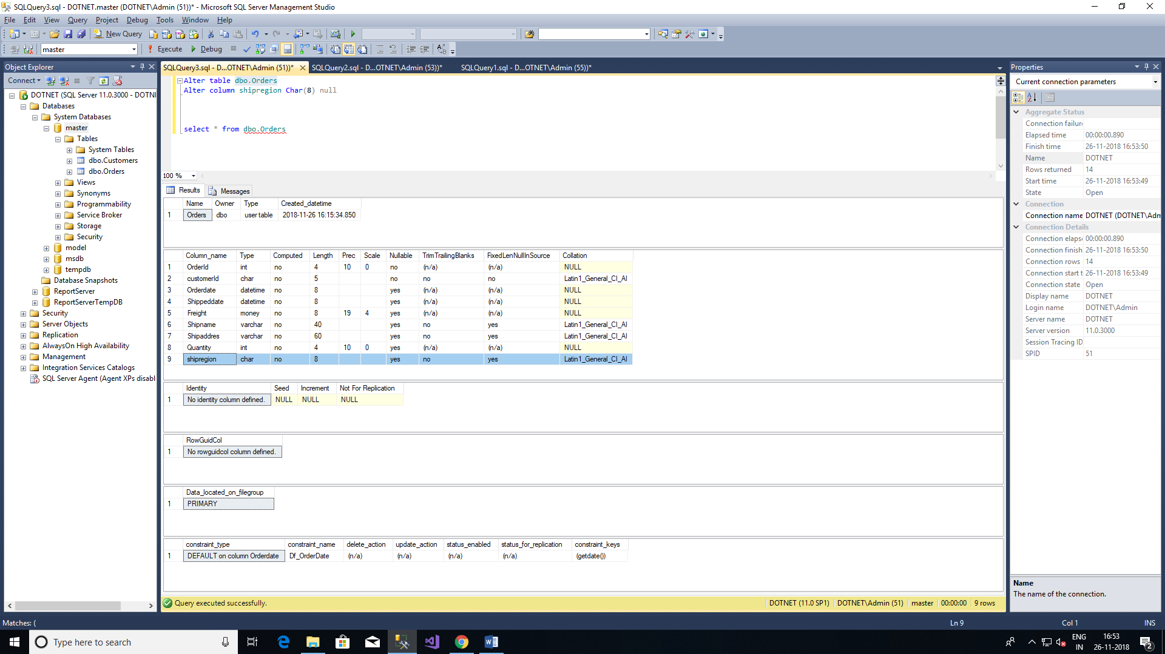

4.Delete Formerly Created column Shipregion

Alter table dbo.Orders

Drop column shipregion

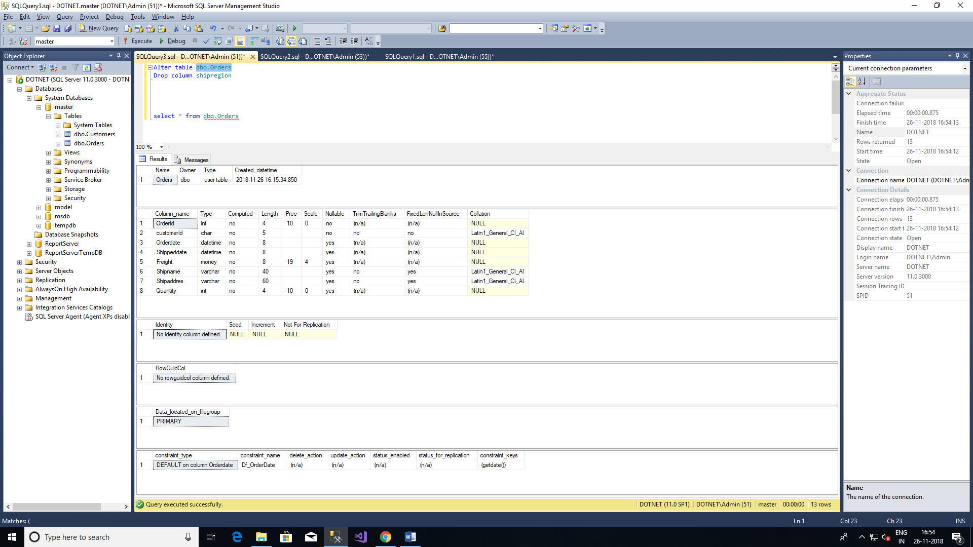

5.Insert new row into Order table

Insert into dbo.Orders

values ( 10, 'ord01', getdate(), getdate(), 100.0, 'Windstar', 'Ocean' ,1)



6.Alter Order table Order Date column to set default value:

Alter table dbo.Orders

Add Constraint Df_OrderDate Default GetDate() for Orderdate



7.Rename Customer table City column to town:

Before Excuting

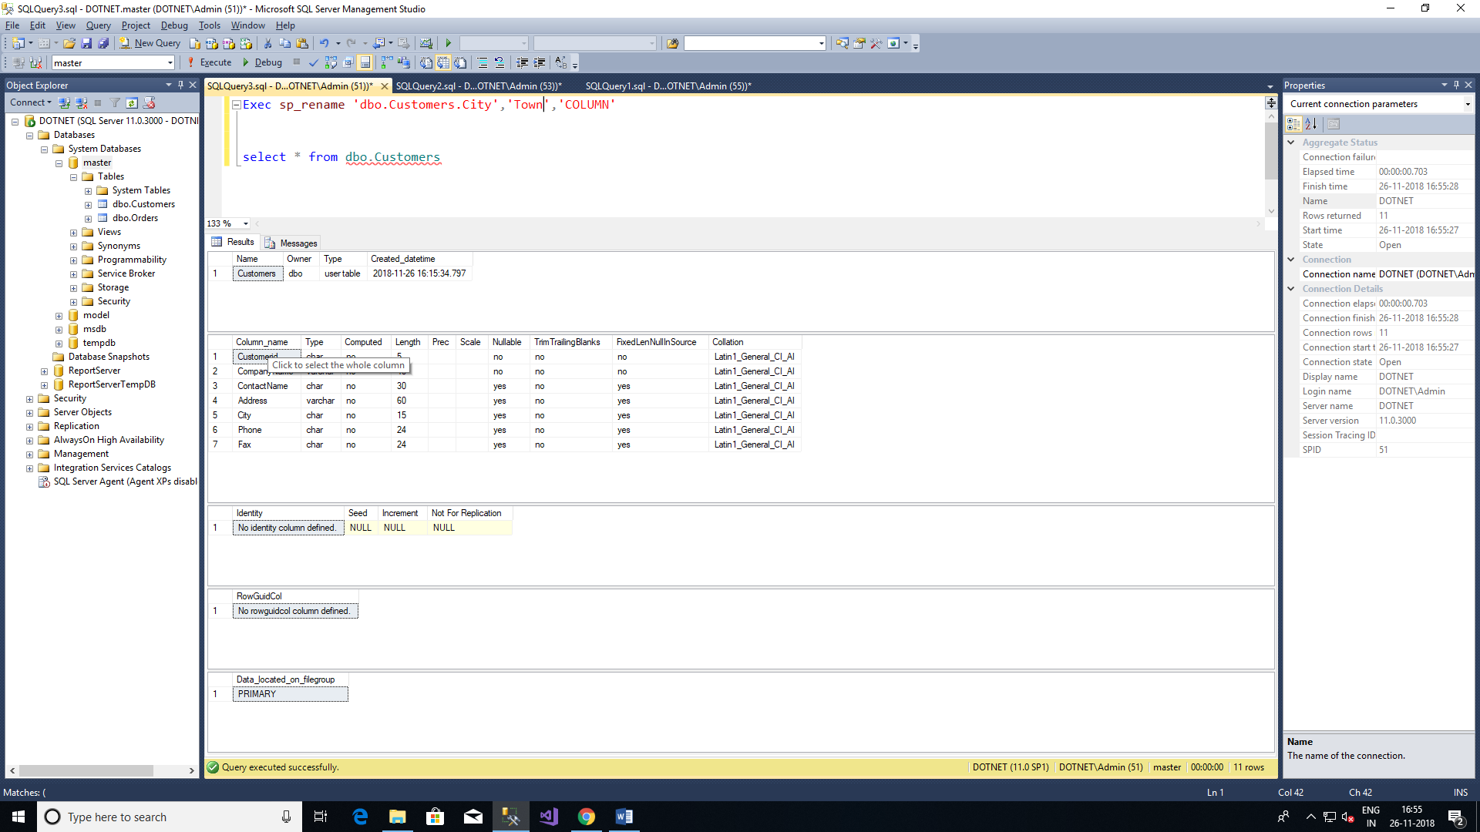

Exec sp_rename 'dbo.Customers.City','Town','COLUMN'

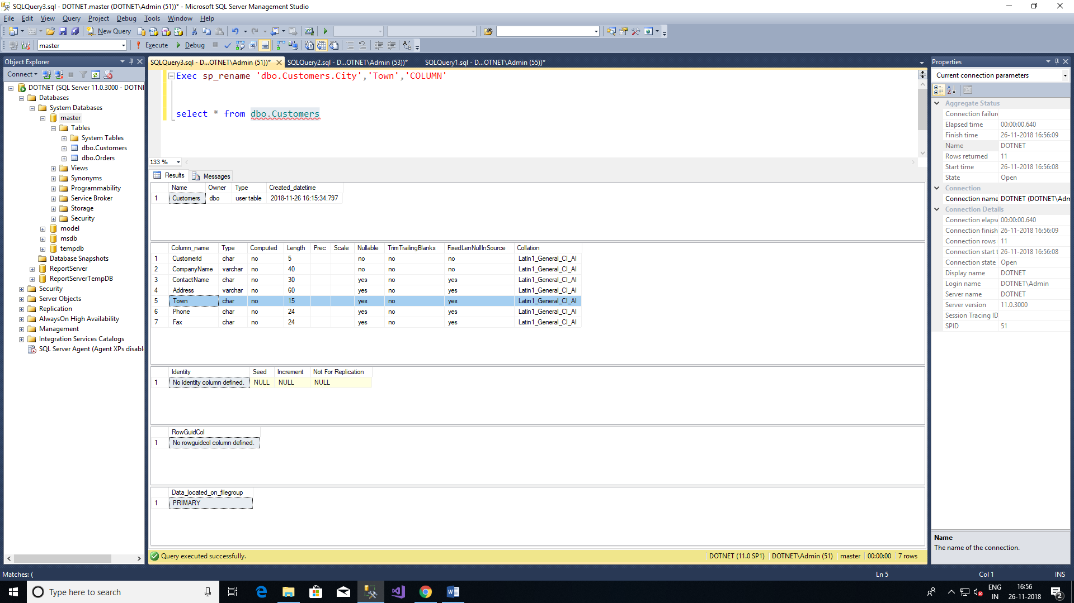

8.Create Table For Deparment,Employee,Project,Work_on & insert records:

CREATE TABLE Department

(

Dept_no Char(10) not null,

Dept_name Char(10) not null,

location CHAR(50) not null

)

Insert INTO dbo.Department values('d1','Res','Dallas');

Insert INTO dbo.Department values('d2','Ac','Seattle');

Insert INTO dbo.Department values('d3','Ma','Dallas');

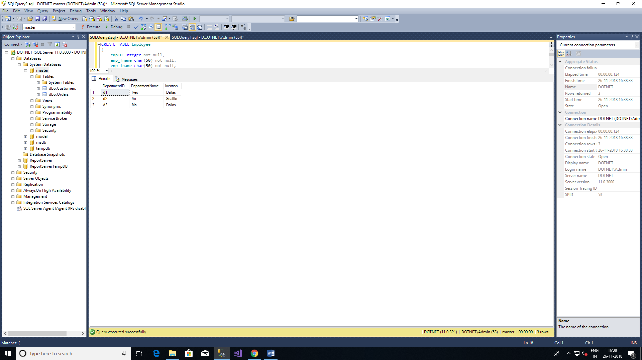

CREATE TABLE Employee

(

emp_no Integer not null,

emp_fname char(50) not null,

emp_lname char(50) not null,

Dept_no Char(10) not null

)

Insert INTO dbo.Employee values('25348','Matthew','Smith','d3');

Insert INTO dbo.Employee values('10102','Ann','Jones','d3');

Insert INTO dbo.Employee values('18316','John','Barrimore','d1');

Insert INTO dbo.Employee values('29346','James','James','d2');

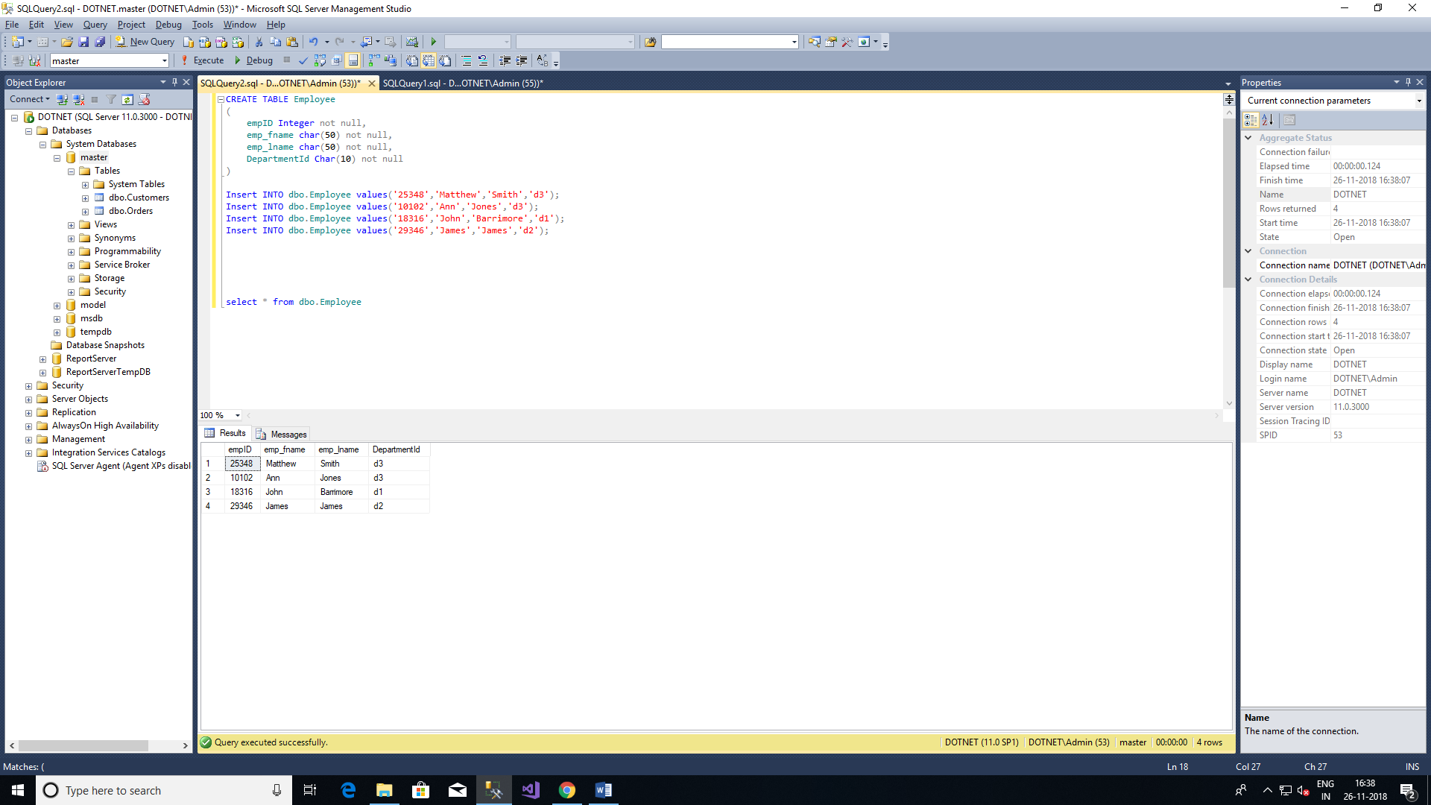

CREATE TABLE Project

(

project_no Char(10) not null,

project_name char(50) not null,

Budget Varchar(50) not null

)

Insert INTO dbo.Project values('p1','Apollo','120000');

Insert INTO dbo.Project values('p2','Gemini','95000');

Insert INTO dbo.Project values('p3','Mercury','18560');

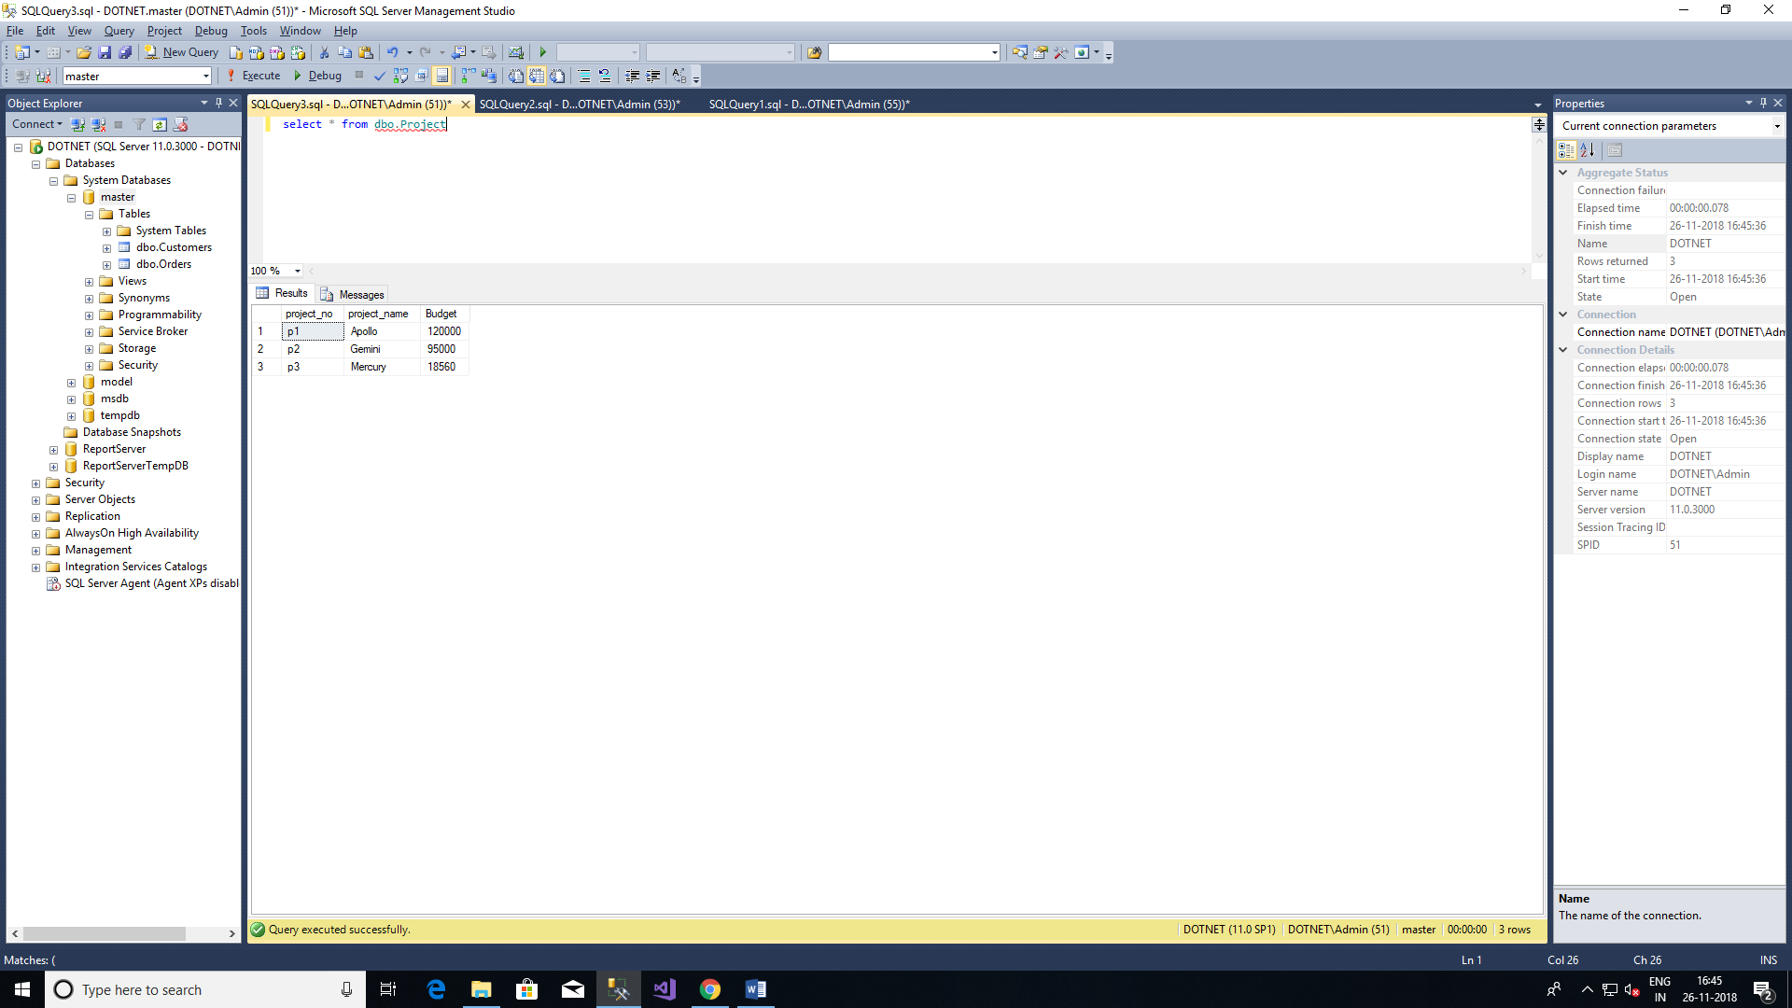

CREATE TABLE Work_on

(

emp_no Integer not null,

project_no char(10) not null,

Job Varchar(50) null,

enter_date date not null

)

Insert INTO dbo.Work_on values('10102','p1','Analyst','1997.10.1')

Insert INTO dbo.Work_on values('10102','p3','manager','1999.1.1')

Insert INTO dbo.Work_on values('25348','p2','Clerk','1998.2.1')

Insert INTO dbo.Work_on values('518316','p2',NULL,'1998.6.1')

Insert INTO dbo.Work_on values('29346','p2',NULL,'1997.12.1')

Insert INTO dbo.Work_on values('52581','p3','Analyst','1998.10.1')

Insert INTO dbo.Work_on values('59031','p1','Manager','1998.4.1')

Insert INTO dbo.Work_on values('528559','p1',NULL,'1998.8.1')

Insert INTO dbo.Work_on values('28559','p2','Clerk','1992.2.1')

Insert INTO dbo.Work_on values('9031','p3','Clerk','1997.11.1')

Insert INTO dbo.Work_on values('529346','p1','Clerk','1998.1.4')

Simple Queries:

1.Get All Row of the work_on table:

Select * from dbo.work_on

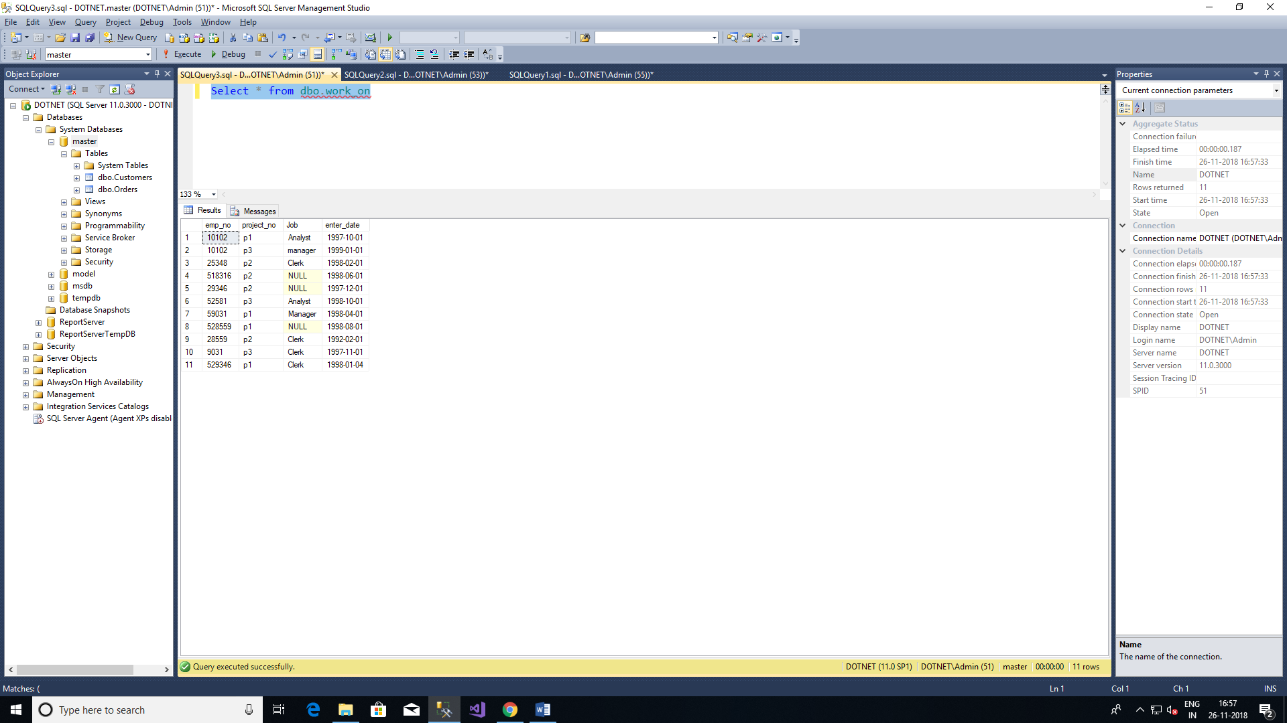

2. Get the employee numbers for all clerks

Select Emp_no from dbo.Work_on Where Job = 'Clerk'

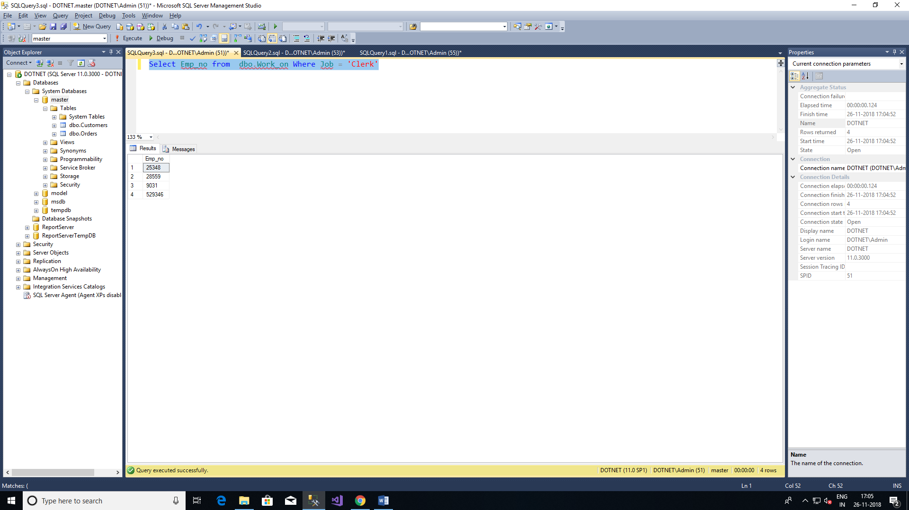

3. Get the employee numbers for employees working in project p2, and having employee numbers smaller than 10000. Solve this problem with two different but equivalent SELECT statements

4. Get the employee numbers for all employees who didn’t enter their project in 1998.

5.Get the employee numbers for all employees who have a leading job( i.e., Analyst or Manager) in project p1

6.Get the enter dates for all employess in project p2 whose jobs have not been determined yet.

7.Get the employee numbers and last names of all employees whose first names contain two letter t’s.

8.Get the employee numbers and first names of all employees whose last names have a letter o or a

as the second character and end with the letters es.

9.Get the employee numbers of all employees whose departments are located in Seattle.

10.Find the last and first names of all employess who entered their projects on 04.01.1998

11.Group all departments using their locations.

12.Find the biggest employee number.

13.Get the jobs that are done by more than two employees.

14.Find the employee numbers of all employees who are clerks or work for department d3